SOFTWARE REQUIREMENT SPECIFICATION

PROJECT GUIDE TEAM MEMBERS

MR. ANOOP PATEL SUNNY SAINI (1130421)

YOGESH SAINI (1130402)

PANKAJ KUMAR (1130512)

Table of Contents

1. Introduction

1.1 Purpose............................................................................. 3

1.2 Scope ...............................................................................3

* 1. Definitions, Acronyms and Abbreviations.........................4

1.4Tools Used ........................................................................5

1.5 Overview...........................................................................5

2. Overall Description

2.1 Software Interface ..............................................................6

2.2 Hardware Interface ............................................................6

2.3 Communication Interface ...................................................6

2.4 Constraints .........................................................................6

2.5 ER Diagram ........................................................................7

2.6 Data Flow Diagram...............................................................8

2.7 Sequence Diagram................................................................10

3. Specific Requirement

3.1 Functional Requirements ..................................................11

3.2 External Interface Requirements .......................................12

3.3 Performance Requirements ...............................................12

Introduction

* 1. Purpose

This is the requirements specification for a simple computer screen Alarm Clock with alarm settings. This document is meant to delineate the features of ALARM CLOCK, so as to serve as a guide to the developers on one hand and a software validation document for the prospective client on the other. It will illustrate the purpose and complete declaration for the development of system. This document is primarily intended to be proposed to a customer for its approval and a reference for developing the first version of the system for the development team.

* 1. Scope  
     We describe what features are in the scope of the software and what are not in the scope of the software to be developed.

In Scope :

* There is one basic user – Client.
* Application on system start-up.
* Shows current processor time.
* Client can set/edit the alarm time.
* Alarm for nearly one minute.

Out of Scope :

* Multiple alarms.
* Snooze.
  1. Definitions, Acronyms and Abbreviations
* Clock  
  A device that has its own value of time in hours, minutes and seconds, which it displays and which it maintains accurately relative to when the time was last reset. In this document, a "conventional clock" means such a clockwork or electric device in the real world; "clock" means a computer operating system function that returns at least an absolute or elapsed time as measured by the operating system.
* Alarm Clock  
  A device which is a conventional clock with an additional time value setting and an attached alarm bell. When the clock time reaches the time of the "alarm setting" it rings the bell. In this specification, "alarm clock" means the software application that imitates many of the functions of a conventional clock with an alarm.
* Ring the Bell  
  The continuous alert sound (the term "audible signal" is too pedantic!) that an alarm clock can make. It may be a buzzer or chime or other tone (compare mobile phone "ring tones" which no longer resemble a bell).
* Clock Time  
  The time relative to the last reset of the clock.
* A Clock  
  The Alarm Clock application.
* Digital Display Format

Two digits for each components of the time (hours, minutes, seconds if any) separated by a colon ":".

* 1. Tools Used
* Code::Blocks

Code::Blocks is a full-featured IDE (Integrated Development Environment) aiming to make the individual developer (and the development team) work in a nice programming environment offering everything he/they would ever need from a program of that kind. Its pluggable architecture allows you, the developer, to add any kind of functionality to the core program, through the use of plugins...

* 1. Overview

This document is a first draft requirements specification for a software application emulating a simple  
alarm clock.

Overall Description

2.1 Software Interface

Windows Operating ystem.

2.2 Hardware Interface

Intel Processor.

2.3 Communication Interface

A computer WIMP (WINDOWS ICON MENUS POINTER)interface to the extent of starting the application, selecting the application's window, minimising or hiding the window, resizing a window, selecting the window for input focus, typing a little.

2.4 Constraints

* GUI is only in English.
* Limited to Windows users.
* Works only on Intel Processors

2.5 ER Diagram

Entity relation diagram is a graphical representation of participating object /sub programs /data base/ data storage.

Entities Attributes :

* Primary Key Attributes.
* Multi Value Attributes.
* Composite Attributes.

Entities :

* Alarm Time.
* Processor Time.
* Sound Function.
* Clock.

ALARM

CMP

TIME

GIVE

TIME

PROCSSOR

(1970)

SOUND

SYSTEM

AXPT

SOUND

TIME

FROM

CLOCK

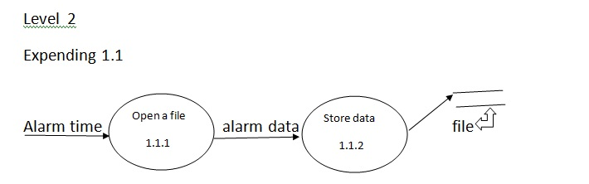

2.6 Data Flow Diagram

A diagram in which we show that how data is transferred from one module to another module.

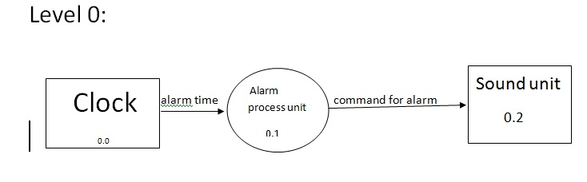

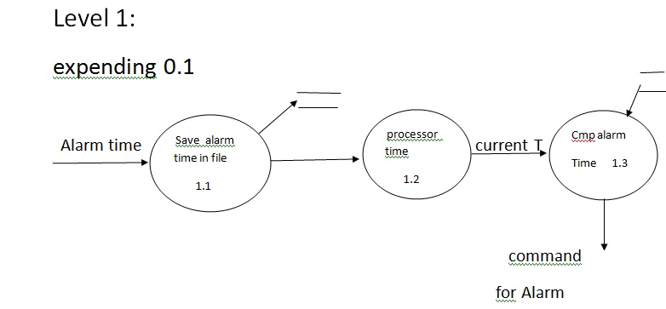



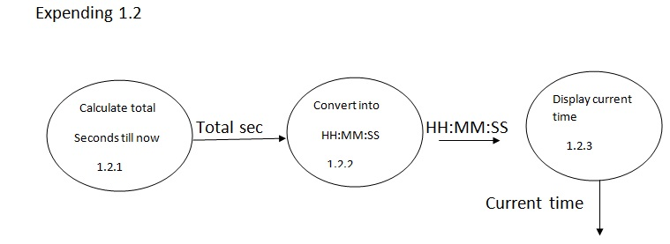

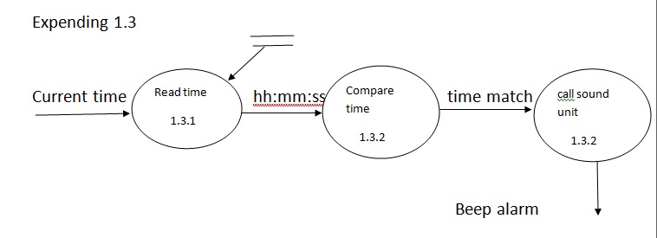

2.7 Sequence Flow Diagram

It define the interaction of subprogram in different manner.

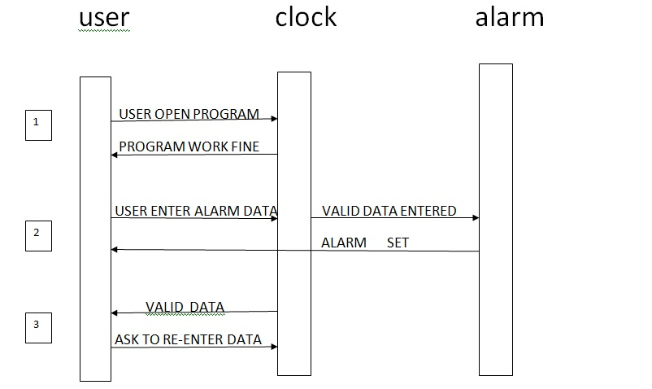

Specific Requirements

* 1. Functional Requirements

Basic clock operations  
 **3.1.1**

The alarm clock shall maintain a current time on a cycle of 24 hours reflecting intervals of time accurate to plus or minus 1 second compared to the processor clock.

**3.1.2**  
 The display style of the clock shall be any combination of a *format*, *precision*, and *cycle length*:

**Format :**  
Digital format.  
**Precision :**

Hours, minutes and seconds.

**Cycle Length :**  
24 hours.

**3.1.3**  
 The alarm clock shall display its current time in a current display style, in its WIMP window.

**3.1.4**  
 The size of the display and its graphical and character elements shall be as large as possible within the display window.

***Alarm operations***  
**3.1.5**The alarm clock shall have zero or one alarm settings.  
**3.1.6**  
The user shall be able to add new alarm settings.  
**3.1.7**  
The user shall be able to delete alarm setting.  
**3.1.8**  
The user shall be able to inspect alarm settings.  
**3.1.9**  
An alarm setting shall refer to a particular time on a 24 hour cycle.  
**3.1.10**  
The user shall be able to turn an alarm setting ON or OFF.

**3.1.11**  
The alarm clock shall ring the alarm bell whenever any alarm setting is *active*.

**3.1.12**

The application should run at starting of system.

3.2 External Interface Requirements

**3.2.1**  
The alarm clock shall use a single window for the display, with a menu for command.

3.3 Performance requirements

**3.3.1**The alarm clock shall maintain its time accurate to within one second of the processor clock.

**3.3.2**  
The alarm clock application shall consume less than 1% of the CPU on any system.

**3.3.3**  
The alarm clock application shall require less than 30MB of memory while executing.